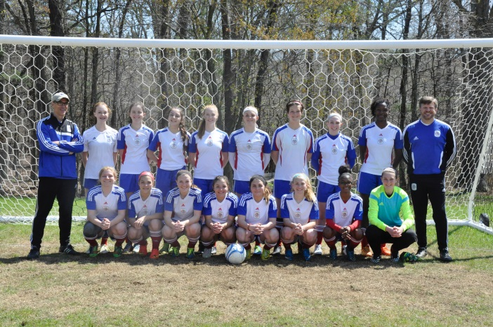 That’s Me!
Coach John Ouellette

** More than 10 years of Coaching experience at the Travel and County Levels. Participated in over 60 Regional/Local Tournaments and College Showcases

Currently Head Coach for the:
ASA Attack U17G WAGSL D1
ASA Attack U11G AAYSA D1

** Have and maintain the NSCAA Regional Diploma and USSF E Licenses

