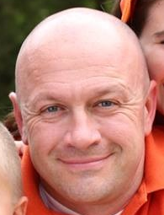

Coach Shawn Ralston
Team Age Year: 2006
Fall 2016 League: High CMSSL
Coaching Experience: "E" License Certified 2015; Coached 15 (10 boys, 5 girls) sessions of youth soccer across recreational and county leagues; Have served as youth referee for 2 years
Playing Experience: Played for Baltimore Kickers in Amateur Leagues throughout Maryland; Played for multiple "All Service" and "All-Air Force" teams across numerous local and regional leagues; Coached and played numerous recreational teams (indoor, outdoor)
Team Philosophy: Focus is dependent on the age of the team and maturity of the players in their physical and mental development. Team play is central focus, while building individual development within and beyond current skill levels. Players are expected to be accountable to themselves and their teammates in an environment that constantly pushes their skills beyond current levels.
Players will be expected to play in the Spring and Fall sessions, along with a summer camp for development and winter indoor or futsal games only to maintain development. Additional sports are accommodated and can lead to further developed, well-rounded athletes.

