Coach Steve Shehade Bio
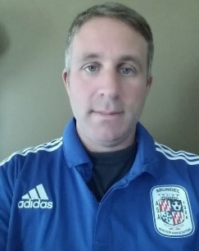
Introduction:
My name is Steve Shehade and I will coach a 2005 (birth year) Boys county D4 team, with the intention of trying to move up to D3. I have been coaching with ASA for a little over 6 years now. I am a father of two kids one boy and one girl. I grew up in the Gambrills area attending Arundel Middle/High school, and attended Towson University. While growing up in the area most of my life I have played multiple rec sports including; lacrosse, football, soccer, basketball, and baseball. Practice days are usually Wednesday and Friday but can change
I also currently help as an assistant coach for a 2007 (birth year) girls D1 travel team (WAGS) with Head Coach Richard Wilson.
Background:
I have also served as a head coach and Boys Lacrosse Commissioner for the Gambrills-Odenton Recreation Council (GORC) since 2009. I have coached football, baseball and lacrosse. My main focus the past several years has been centered on lacrosse and soccer programs.
League Play:
I currently plan to coach in the county D4 Boys league, with the intention of trying to move up into the D3 level. I may look to do one tournament a year that fits our level of play and usually at the beginning of the season. While currently at the county D4 level, I am looking for a level of commitment from a player who wants to advance himself skills wise to make a jump to the next level of D3. With that I am looking for a commitment from a player and the parent who are willing to make that transition.
Philosophy:
I have always had a love and passion for coaching youth sports. I have a basic set of principles when it comes to coaching; first and foremost is to make sure the kids are having fun, then to give the kids the tools they need to develop their skills and advance, and to teach the kids teamwork on and off the field. I want to see kids succeed and believe in preparing kids on and off the field.
I think that players get better with game time so playing time will be close to even as I can. The development of ball skills is always a practice focus in addition to passing, receiving and moving without the ball.

